🏆 TECHARA CHAINLEARN ACADEMY

India’s First All-in-One Web3 Academy

(Blockchain | Crypto | NFT | DeFi | Web3 Development)

PG MASTER BLOCKCHAIN CERTIFICATION COURSE

Subject Code: MB-101
Subject Name: Bitcoin & Blockchain Fundamentals

📅 Academic Year: 2026
⏳ Duration: 3 Hours

Month: 1
📊 Total Marks: 150
📍 Mode: Written + Practical + Transformation

MASTER BLOCKCHAIN COURSE

📅 Month 1 Examination – Bitcoin & Blockchain Fundamentals
⏳ Total Duration: 3 Hours
📊 Total Marks: 150

MARK DISTRIBUTION SUMMARY
Section | Marks
Part A – 1 Mark | 40
Part B – 5 Marks | 40
Part C – 10 Marks | 40
Part D – Practical | 20
Transformation | 10
TOTAL | 150 Marks

🟢 PART A – One Mark Questions (40 × 1 = 40 Marks)

- Who created Bitcoin?
  - Santhoshi Nakamuki
- In which year was Bitcoin launched?
  - 2009
- What is blockchain?
  - Peer to peer transaction,
  - Decentralization

- What is a block?
  - Contain header and body
- What is a hash?
  - It’s a alphanumeric value has fixed length – 64 bits
- What algorithm does Bitcoin use?
  - SHA 256 Algorithm
- What is Proof of Work?
  - Verifies the transaction
  - Mining process
  - Transaction fee generated
  - Eg: Bitcoin
- What is Proof of Stake?
  - Cryptos are kept for a long period of time
  - Eg: Ethereum
- What is a nonce?
  - It is process of solving complex mathematical puzzles by miners
- What is mining?
  - Process of generating new Bitcoin
- What is a node?
  - System + Bitcoin Server
- What is a full node?
  - Contain: Previous Block, Hash, Transaction Details, Network Server
- What is a light node?
  - Network Server, Block
- What is UTXO?
  - Unsend Transaction Exchange
  - Used to Prevent Double Spending
- What is a wallet?
  - Storage of Private and Public key
  - Formed by Cryptography
- What is a public key?
  - Automatic generated key with size 64 bits
  - Its public address through which transactions are sent
  - Used – Validation and Encrypt
- What is a private key?
  - Every public address has separate Private key
  - 12 -14 String (64 bits)
  - With private key signature and decrypt
- What is a digital signature?
  - Authorizers who sent the transaction
  - Made with sender’s Private key
- What is block reward?
  - Miners get block reward for solving complex mathematical puzzles
- What is halving?
  - Reducing 50% of Reward points for every 4 years once
  - At present reward – 3.125 BTC
- What is consensus?
  - Its mechanism of POW and POS
- What is distributed ledger?
  - Transaction Details are stored in ledger, and they are distributed to all the blocks in Blockchain
- What is Testnet?
  - Bitcoin Blockchain
- What is Regtest?
  - Ethereum Blockchain
- What is Mainnet?
- What is mempool?
  - Its waiting area after transaction initiated
  - Form here mining process starts
- What is block time in Bitcoin?
  - 10 mins
- What is double spending?
  - Sending 1 BTC more than one time for n number of transactions
  - Here amount in sender’s wallet doesn’t get debited
- What is Merkle Root?
  - It is combination of transactions in tree structure
  - Minimum storage
- What is block header?
  - Contain – Prv. Block, Hash Timestamp, Block version, difficulty, Nonce
- What is genesis block?
- What is decentralization?
  - Node is connected with each other. If any changes made in 1 node that will reflect to all nodes
- What is peer-to-peer network?
  - One node is connected with another node directly without any intermediates
  - Eg: Blockchain used P2P transaction
- What is difficulty adjustment?
  - Mining increases, difficulty increases
- What is smart contract?
  - It is coding made by Ethereum Blockchain
- What is gas (basic definition)?
  - Amount of fuel used in transaction – used in ETH
- What is SHA-256?
  - Sharp Hash Algorithm used in Bitcoin Blockchain
- What is cryptography?
  - Symmetric and Asymmetric
  - [Hash + Private key + Public key + Digital signature]
- What is blockchain explorer?
  - Search area where exchanges are listed
- What is mining pool?
  - It’s a waiting area where mininers solve complex puzzles

🟡 PART B – 5 Mark Questions (Answer Any 8) (8 × 5 = 40 Marks)
- Explain Proof of Work (PoW) in detail.
  - POW is consensus mechanism used in Bitcoin Blockchain
  - With this mechanism new Bitcoin are mined
  - Process:
    - 1st transaction-initiated form Sender’s Wallet and set transaction fee
    - BTC moved to Bitcoin Explore
    - Mining pool – is waiting area here miners solve complex mathematical puzzles
    - Solved puzzles value will be Nonce
    - Nonces created the Block and move the block into Blockchain
    - Miners get Block reward as BTC, Transaction fee
- Explain Proof of Stake (PoS) and compare it with PoW.
Proof of Work | Proof of Stake
Used for mining BTC | Used for Stake crypto
Work under Bitcoin Blockchain | Works – Ethereum Blockchain
Used in transaction of BTC | Used to stake Crypto for n number of period
Miners get New BTC and Transaction fee | Cryptos can hold
Short period | Long period
Used since 2009 | Used since 2015
- Explain how a Bitcoin transaction works step by step.
Bitcoin Transaction work on POW process, it is peer to peer transaction
    - Tiko has wallet, which holds public address and private key
    - Tiko initiated transaction of 2.5 BTC to Tuki by using Tuki’s Public address and setting high transaction fee
    - After Tiko make a Digital Signature using Private key for authorization
    - Amount will be sent to Explore and move to mining Pool
    - In mining pool complex mathematical puzzles are solved and get nonce. This process is done by miners
    - Amounts enter UTXO and verify the transaction
    - UTXO check amount in Tiko wallet and separated 2.5BTC and sent to Tuki’s wallet
    - Later unspent BTC will be sent back to Tiko’s wallet
    - Now Tuki got 2.5BTC from Tiko.
    - Miners get Block reward as 3.125BTC and Transaction fee
    - Nonce add block into blockchain
Here Whole transaction done within 10 mins. While initiating Transaction fee set to high the miners solve the puzzles first.
- Explain UTXO model with diagram.
UTXO – Unspent Transaction Output
    - Main Usage of UTXO is to prevent Double spending
    - It split the BTC as required and Sent to Receiver and split unspent BTC will be sent back to the sender’s wallet

Step 1: Senders Wallet: 1.5BTC 2BTC 3BTC
Trans – 2.5 BTC to receivers
Step 2: UTXO check nearest BTC in sender’s wallet
Eg: want to send 2.5 BTC it will take 1.5BTC and from 2BTC takes .5BTC
Step 3: combining this it will send 2.5BTC to Receiver Wallet
Step 4: Remain unspent BTC will be resent to Sender’s wallet
- Explain Full Node vs Light Node.
Full Node: Wallet, miners, blockchain, network service provider
Light Node: Wallet, Network Service Provider
- Explain Mining Process in Bitcoin.
- Explain Merkle Tree.
- Diffrence between Cryptocurrency,CBDC, Stable coin.
CryptoCurrency | CBDC | Stable coin
It is Digital Currency formd by Blockchain | Centralized Bank Digital Currency – Work by blockchain | Standard coin for a country
Decartelized | Centralized | Centralized
Bitcoin, Ether | e- Rupee | Country’s standard coin
Bitcoin blockchain | Smart contract- Ethereum blockchain | Ethereum blockchain
High Voltage | Stable | Stable
Defi | Smart contract | Smart contract

- Explain Hashing and its importance in blockchain.
  - Hashing is Alphanumeric value generated automatically by using SHA256 Algorithm
  - Hash Size of 64 bit
  - Any small changes in body will reflect to Block
  - Hash is highly secured
  - Hash liked with previous block
- Explain Public Key & Private Key cryptography.
  - Public Key:
    - Generate using Hash Function used for Initiating transaction and used to sent amount to receivers address
    - Uses – Validation and Encryption
  - Private Key:
    - Every public key have unique private key with 12-14 String
    - Uses – Signature and Decryption

🔵 PART C – 10 Mark Questions (Answer Any 4) (4 × 10 = 40 Marks)
- Explain complete Bitcoin block structure with diagram.
- Explain how consensus secures blockchain networks.
- Discuss advantages and limitations of Bitcoin.

- Explain Distributed Systems and their role in blockchain.
- Case Study:
A startup wants to accept Bitcoin payments.
Explain technical, financial, and risk considerations.

🟣 PART D – Practical & Lab Understanding (2 × 10 = 20 Marks)
- Explain the step-by-step process on how cryptography act as a strong pillar of Blockchain Technology.
  - Cryptography has – Symmetric and Asymmetric
  - 4 important terms of Cryptography – Hash, Private key, Public key, Digital Signature
  - Some of practical demo of Symmetric and Asymmetric
Symmetric:
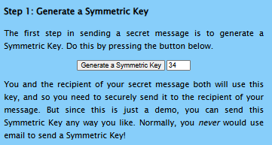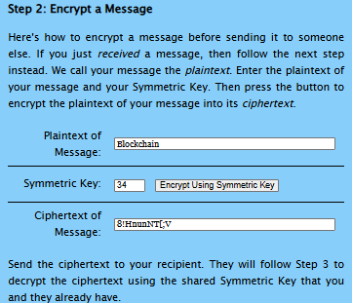

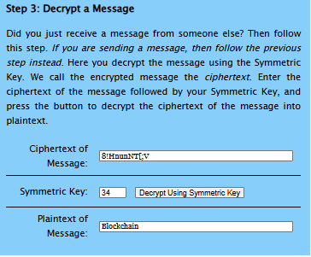
Asymmetric:
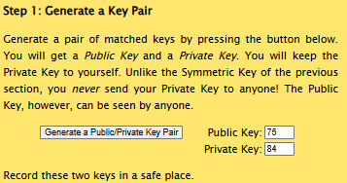
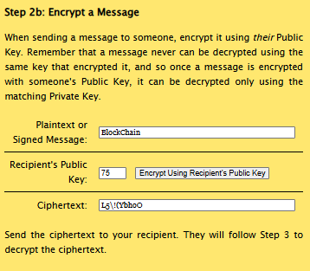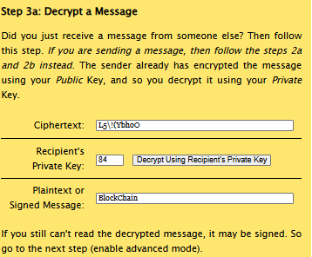
- Explain how Bitcoin Transaction of 1BTC from Cutiee to Beauty is transferred,explain in deep technical aspect .

🟢 TRANSFORMATION ASSESSMENT – 10 Marks
Students must complete all:
1️. Write a short LinkedIn blog (5 Marks)
Topic: “What I Learned from Bitcoin Blockchain”
Here is a simpler and easy-to-read LinkedIn blog (5 marks style):

What I Learned from Bitcoin Blockchain
Learning about Bitcoin blockchain helped me understand how digital money really works.
First, I learned that Bitcoin does not need a bank or central authority. It works on a decentralized network where many computers (nodes) verify transactions. This builds trust without middlemen.
Second, I understood that blockchain is secure and transparent. Once a transaction is recorded, it cannot be changed. This makes the system reliable and tamper-proof.
I also learned how Proof of Work helps secure the network by making miners solve complex problems before adding new blocks.
Most importantly, Bitcoin taught me that technology can create trust through mathematics and code. It is not just digital currency — it is a new way of building secure and open systems.
#Bitcoin #Blockchain #Crypto #Web3 #LearningJourney #FinTech #Decentralization

2️. Record a 1-minute educational video (5 Marks)
Topic: Consensus / Mining / UTXO
Evaluation:
- Technical clarity
- Confidence
- Industry relevance

*********

